BARCOO OUTLET CULVERT – THE INFLUENCE OF SOIL STRUCTURE INTERACTION ON THE DESIGN OF A BURIED ARCH CULVERT

Doug Jenkins, Interactive Design Services

The Barcoo Outlet project in Adelaide was won by Baulderstone-Hornibrook with an innovative alternative design, prepared by Connell-Wagner, requiring the construction of an arch culvert over 700 m long. Reinforced Earth successfully tendered for design and supply of the precast culvert with an alternative design based on their TechSpan system. The influence of soil-structure interaction was considered in the design of both the arch and the precast raft base to achieve economies in the section design, and to check the performance of the structure for varying foundation conditions and fluctuating hydraulic loads.

This paper describes the arch design process, which included both two and three dimensional finite-element analysis for the culvert cross section design, and to check the effect of differential longitudinal loading and foundation conditions. Included in the data presented is a comparison of finite element analysis results with the classical “beam on elastic foundations” theory, and recommendations for procedures to be used in the analysis of deep raft foundations.

- Introduction

The Barcoo Outlet project forms a connection between the Patawalonga Lakes and the Sea to the West of Adelaide. The purpose of the project is to improve environmental conditions in the lake by diverting stormwater flows directly to the sea. Baulderstone-Hornibrook won the design and construct contract with an innovative design by Connell-Wagner. The Connell-Wagner design avoided the need for large pumps by using a venturi system, which required a closed duct for the full length of the outlet. Reinforced Earth designed and supplied a precast concrete arch culvert based on their TechSpan system.

- The tender design

The tender documents for the culvert supply contract included an arch culvert design by Connell Wagner (Figure 1). The main features of the tender design were:

- A one piece arch of approximately elliptical section and 225 mm thickness.
- A precast flat slab base of varying thickness, depending on the fill height.
- Ship lapped joints in the base and arch designed to provide transfer of load in the event of differential settlement.
- The design brief required the culvert to be waterproof for the extent of the construction and defects liability period, and sand-proof for the design life of 100 years.
- Design loading requirements included fill levels of 2 to 14 metres over the crown, and differential hydraulic pressure due to tidal variation and wave action.
- About 200 metres of the culvert was to be constructed below sea level, inside a coffer dam.

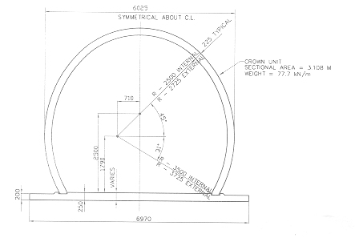
Figure 1: Cross Section; Connell-Wagner Proposal

- The Reinforced Earth proposal

Reinforced Earth submitted an alternative design for the culvert, which while closely following the Connell-Wagner concept, achieved additional economies in materials and improved ease of manufacture, transport, and erection. A cross section of the Reinforced Earth design is shown in Figure 2. The main features are:

- The single piece arch was replaced with a two piece design, allowing transportation as a standard truck load.
- Revision of the arch profile, and analysis of soil-structure interaction effects, allowed reduction of the arch thickness to 150 mm.
- A tapered design for the base slab reduced hogging moments in the centre of the slab, allowing savings in reinforcement and concrete quantities.
- The ship-lap arrangement at joints was revised to improve ease of construction.
- The crown joint utilises formed concrete surfaces, rather than the normal Techspan detail of galvanised steel plates. The use of exposed galvanised steel was avoided because of the marine conditions.
- The durability requirements of the conforming design were maintained. These included provision of grade 50 concrete with 50 mm minimum cover to reinforcement, and tight limits on maximum crack width and steel stress.

Reinforced Earth were awarded the contract for design and supply of the culvert in August 2000. The contract included responsibility for the design of the culvert, waterproofing, and sand-proofing.

- Transverse analysis

The transverse analysis of the arch and raft slab essentially followed standard Reinforced Earth procedures for buried arch design. A two dimensional plane strain finite element analysis is used, in which the backfill loading is applied in layers,

modelling the actual backfill sequence. It has been found that modelling of the backfill sequence is essential to obtain realistic results in the analysis of buried structures. The analysis incorporates non-linear fill properties, and provides a layer of friction elements around the arch to allow for slip at the soil/concrete interface. Part of a typical finite element mesh is shown in figure 3.

The base slab and foundation soils were modelled in sufficient detail to allow the base slab design forces to be taken directly from the finite element output. A large number of separate analysis runs were required to evaluate:

- Fill heights over the arch crown of between 2 and 14 metres.
- Serviceability and ultimate limit state analyses.
- Dry and saturated conditions (the arch was located below the water table, but was constructed and backfilled in the dry).
- Differential stiffness conditions for foundation soils.
- Vehicle loading due to road vehicles and sand moving vehicles on the beach.
- Differential water loading due to tidal and wave action.
- The effects of possible scour of the sand backfill in the sea section, combined with wave action.

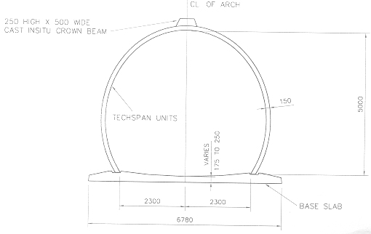
Figure 2: Cross Section; Reinforced Earth Proposal

- Longitudinal analysis

A longitudinal analysis was required to investigate the following effects:

- Differential foundation stiffness under high fills.
- Variation in fill height causing longitudinal bending.
- Changes in behaviour at joints in the longitudinal crown beam.

The foundation soils were modelled using 20 node brick elements, the arch units using plate elements, and the base slab and crown beam using beam elements. Fill loads were
Figure 3: Typical finite element mesh detail

applied as nodal loads to the outside of the arch elements, and to the top of the foundation elements. Vertical loads were estimated from a 2D finite element model of the finished fill surface above the arch. Horizontal load coefficients were extracted from the transverse analysis. A typical stress plot output is shown in Figure 4.

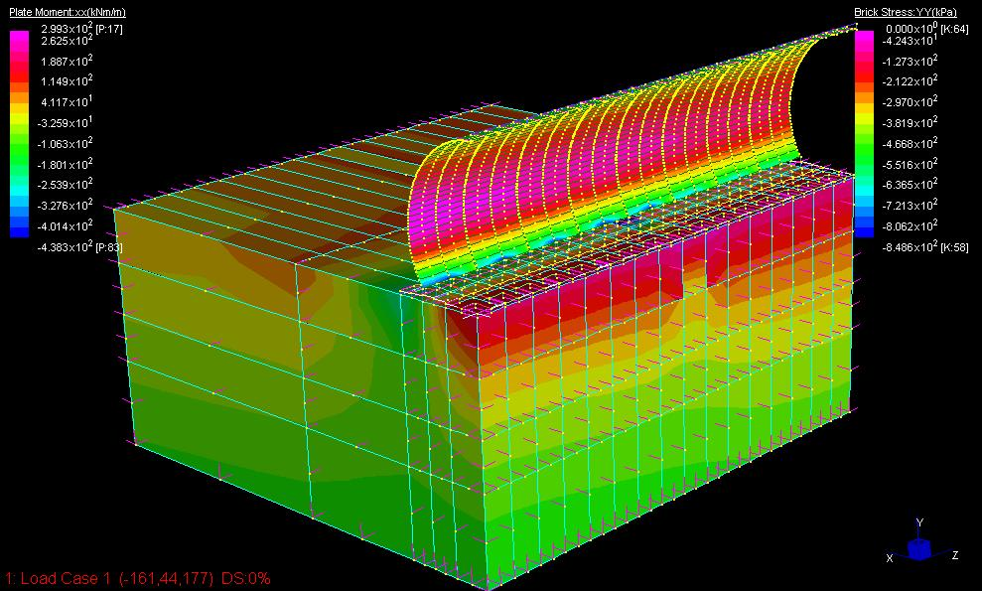
Figure 4: Longitudinal Analysis Output

- Analysis of the raft slab

The design forces for the base raft slab were taken directly from the transverse finite element analysis. Stiffness parameters for the foundation soils were supplied by PPK – Adelaide. The response of the slab is sensitive to the stiffness of the soil immediately under the slab, so separate analyses were run with upper and lower bound stiffness values, and with varying stiffness values across the width of the slab. To check the results of the Reinforced Earth in-house finite element analysis program “Aztech”, the slab was checked with two different types of analysis in Strand7; a 2D plane strain finite element analysis, and an analysis using beam elements with a “beam on elastic foundations” support. The Aztech and Strand7 finite element results were found to be in good agreement. Further details of the beam on elastic foundations results are given below.

- comparison of tapered raft with flat slab

In the course of the design development the moments in the tapered raft used in the final design were compared with a flat slab, of the same maximum thickness. Typical results are shown in Figure 5, showing a substantial reduction in bending moment for the tapered raft.
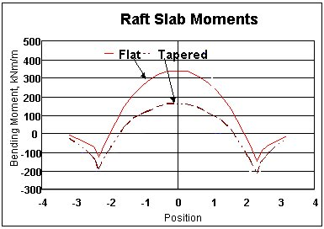
Figure 5: Bending Moments in Flat and Tapered Rafts, (“Aztech” results)

- effect of varying soil stiffness

The raft design was checked for the effect of variable foundation conditions. Typical results are shown in Figure 6. Bending moment diagrams are plotted for:

- Stiff foundation, Young’s Modulus = 100 MPa
- Typical stiffness for the Barcoo Outlet, Young’s Modulus = 50 MPa
- Soft foundation, Young’s Modulus = 10 MPa
- Variable foundation, Young’s Modulus = 10 MPa (edges); 50 MPa (centre)

It can be seen that moments in the raft are sensitive to the stiffness of the foundation. In particular, assumption of a foundation stiffness that is too high will result in un-conservative results.
Figure 6: Bending moments in raft with varying foundation stiffness (“Aztech” results)

- Comparison of Finite Element and Beam on elastic methods

The forces in a uniform foundation supported on a semi-infinite elastic medium can be determined using a simple closed form formula. This provides a simple and quick analysis, and the solution is theoretically exact for a beam on the ground surface. However there are a number of disadvantages:

- The formula uses a “modulus of sub-grade reaction” which depends on the dimensions of the foundation as well as the stiffness of the soil, and thus cannot be determined directly from laboratory test results.
- It is difficult to model layered foundations.
- Non-linear and non-elastic soil behaviour is neglected.
- In the normal formulation the stiffness of the raft and the foundation soil is assumed to be uniform.
- The formula is not valid if the raft lifts off from the soil at any point.
- The effect of the fill pressure outside the limits of the raft is not included.
- The loads applied by the arch must be taken from a finite element analysis, or found by an approximate method.

In spite of these disadvantages the beam on elastic foundations method is widely used. The results of the finite element analysis for the Barcoo Outlet project were compared with a beam on elastic foundations analysis carried out using Strand7, which provides an “elastic foundation” support to beam elements. This enabled the raft and foundation stiffness to be varied across the width of the model. The purpose of the comparison was:

- To compare the results of the two different types of analysis.
- To find a relationship between Young’s Modulus and the Modulus of Subgrade Reaction for deep raft foundations.

Determination of the modulus of subgrade reaction is a fundamental problem with the beam on elastic foundations method. In this study the modulus value was adjusted by trial and error so that the maximum moments agreed with those found in the finite element analysis. Figure 7 shows the bending moment diagram for a 20 metre high fill. The two methods of analysis were found to give reasonably good agreement over the full width of the arch, with the finite element analysis giving slightly higher negative moments.

Figure 7: Moments from Finite Element Analysis and Beam on Elastic Foundations

Figure 8: Maximum Bending moments

The maximum bending moments for flat and tapered raft slabs are shown in Figure 8. The two methods of analysis gave identical results for maximum moment due to the back calculation of the modulus of subgrade reaction in the beam on elastic foundations analysis. It can be seen that:

- The bending moment in the tapered raft was reduced by a factor of up to 2.
- Maximum bending moments were approximately proportional to fill height.

Figure 9 shows the modulus of subgrade reaction required in the beam on elastic foundations analysis to give the same maximum bending moment as the finite element analysis.

- The modulus value varies over a range from 7.4 MPa to 41 MPa, a ratio of almost 6 to 1.
- The modulus value is affected by both the raft stiffness and the fill height.
- Modulus values found in this study are less than, or at the bottom end of the range of typical values quoted in foundation engineering literature.
- In this study the raft span and the foundation soil modulus were kept constant; variation in these factors would also have a large effect on the modulus.

Figure 9: Modulus of Subgrade Reaction

- Recommendations for RAFT slab analysis.

The bending moments in raft slabs are found to be very sensitive to the stiffness of the foundation soils. For this reason it is recommended that a finite element analysis is used for the raft design, using measured values for the elastic modulus of the foundation. If measured values are not available a conservative (low) estimate should be used.

A beam on elastic foundations analysis can give results consistent with finite element analysis, provided that appropriate values are used for the modulus of subgrade reaction. Unfortunately the modulus value is affected by the geometry and stiffness of the raft and the depth of fill, as well as the stiffness properties of the foundation soils. Due to the large number of variables involved, the only practical method to determine the modulus value is to calibrate the beam on elastic foundations analysis against a finite element analysis. The need for calibration removes the advantage of simplicity of this method, and in most applications a finite element analysis will be preferable.

Typical modulus of subgrade reaction values quoted in foundation engineering text books are intended for use with shallow foundations, typically with a single point or line load. Use of these values with deep raft foundations will often give misleading and unconservative results, and is not recommended.

- summary

The use of finite element analysis at the Barcoo Outlet project allowed economies in the design of a pre-cast concrete arch culvert.

The culvert design considered both transverse and longitudinal loads, and considered the effect of variable foundation conditions in both directions.

The stiffness properties of both the raft slab and the foundation soils were found to have a significant effect on the bending moments in the raft. It is therefore important that conservative values be used for the foundation soil stiffness, and the effect of variable stiffness be considered.

A comparison of the finite element analysis results with a beam on elastic foundations analysis found that consistent results could be obtained by adjusting the modulus of subgrade reaction. The appropriate value for the modulus of subgrade reaction is affected by a large number of variables; it is therefore recommended that the beam on elastic foundations method only be used if it can be calibrated against a finite element analysis.

